|  |  |  |  |  |  |
| --- | --- | --- | --- | --- | --- |
| Date | 29-Nov-22 | | | Tester Name | Andrew McLaughlin |
| Environment | Penfax - Test | | | Login used |  |
| Operating System | Select OS | Version: | Update: | | |
| Software Used | Select Software | Version: | Update: | | |
| Select Software | Version: | Update: | | |
| Release version | 22.4.1 | | | | |
| Title | Death – Single Pensioner Calculates Onetime payment for death payout | | | | |
| Test Type | Regression | | | | |
| Test Scenario | Death – Single Pensioner Calculates Onetime payment for death payout | | | | |
|  |  | | | | |
| Expected Results | When a pensioner dies with their estate as the beneficiary, their remaining payments should be paid out in a lump sum.  We should be able to produce a one-time payment equal to their income benefit * periods remaining in guarantee period. | | | | |
| Pass/Fail | Pass | | | JIRA# | N/A |

Member has their estate as their beneficiary

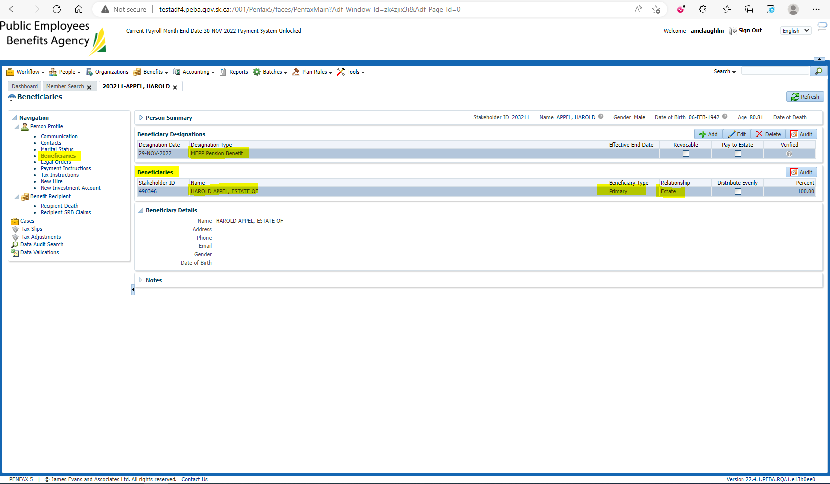

Pension amount is $1,341.28

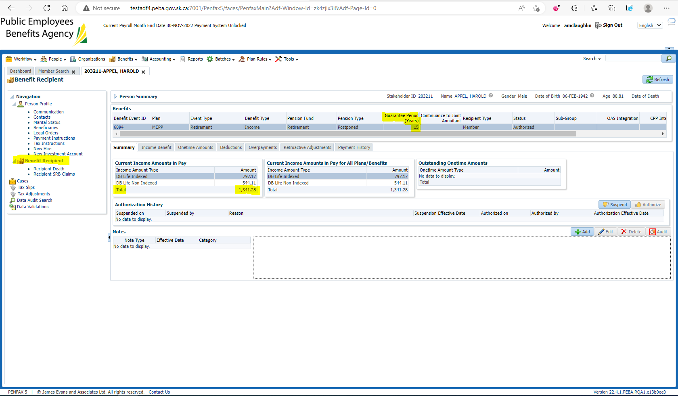

Enter Death Date:

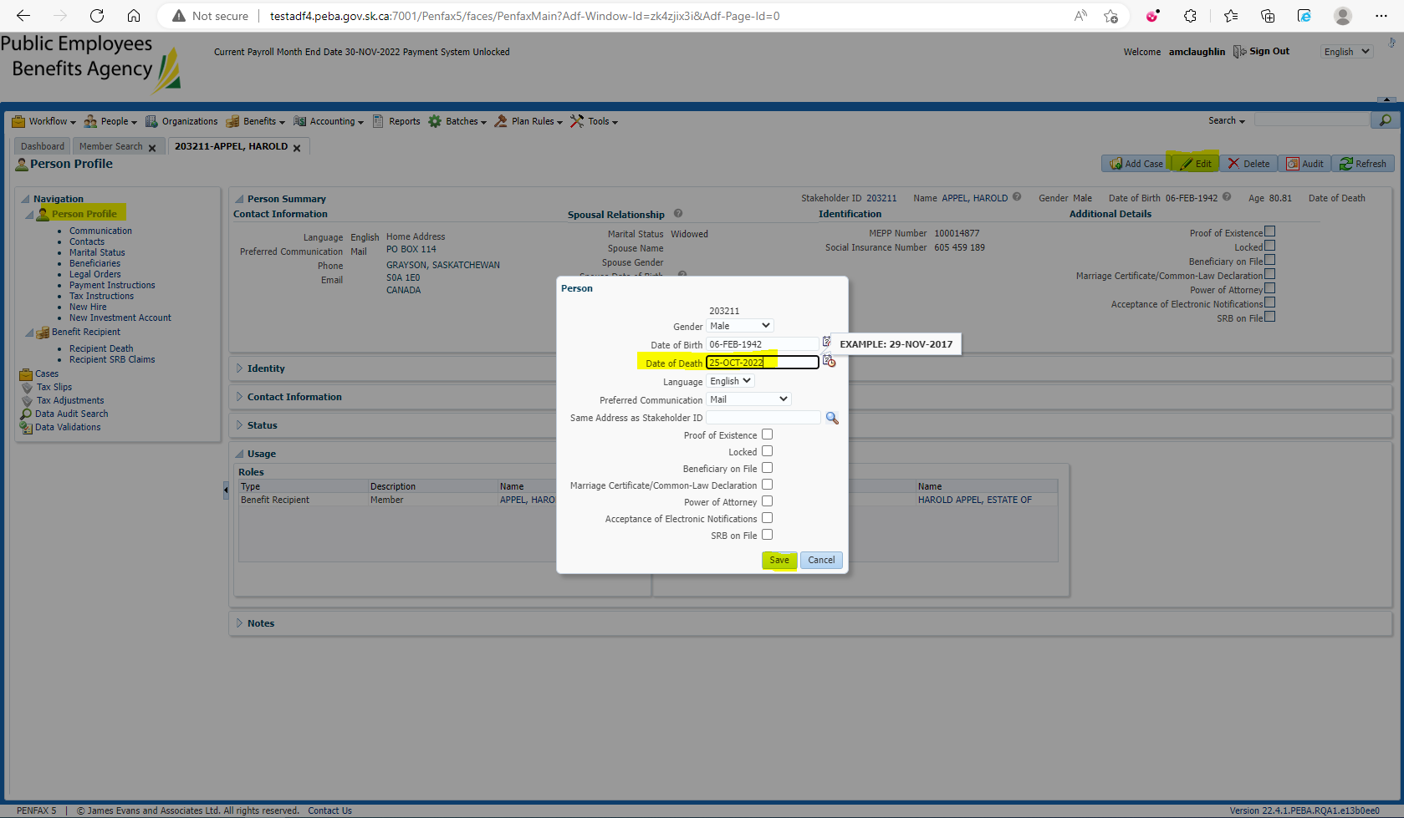

Verify the Retirement/Event Date in the Member’s Benefit Event – 01-JUN-2010:

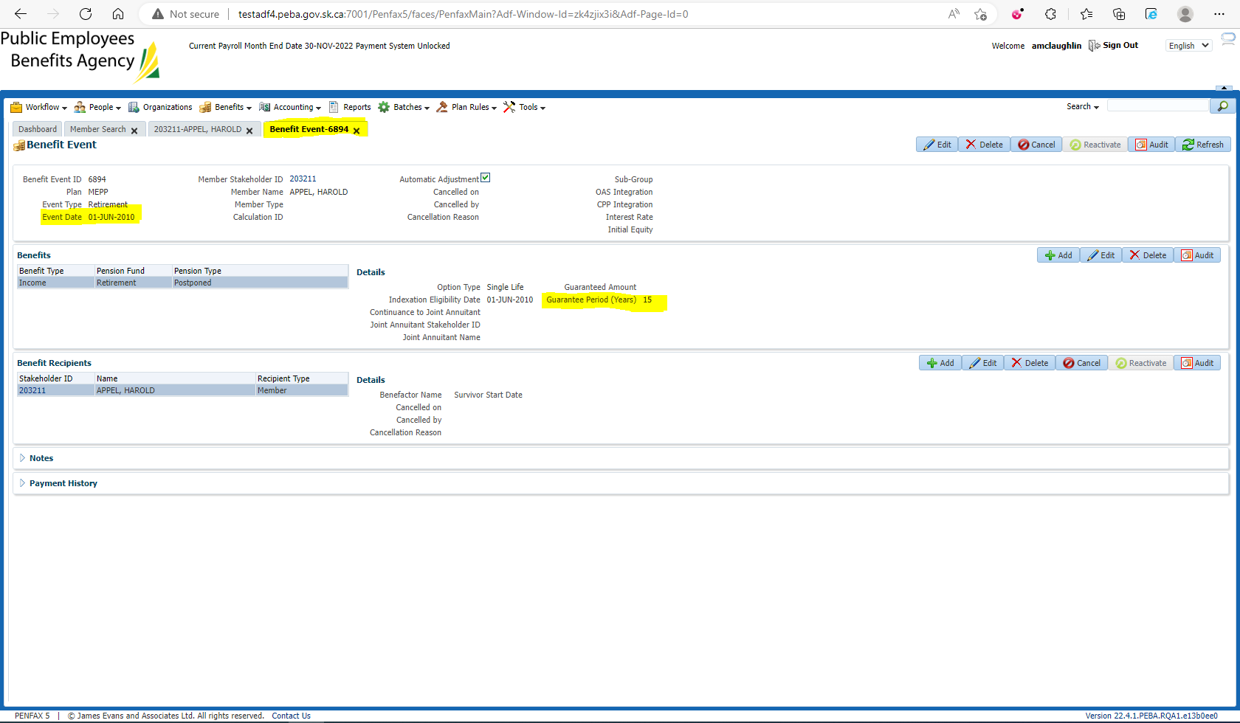

Open the Death Calc: 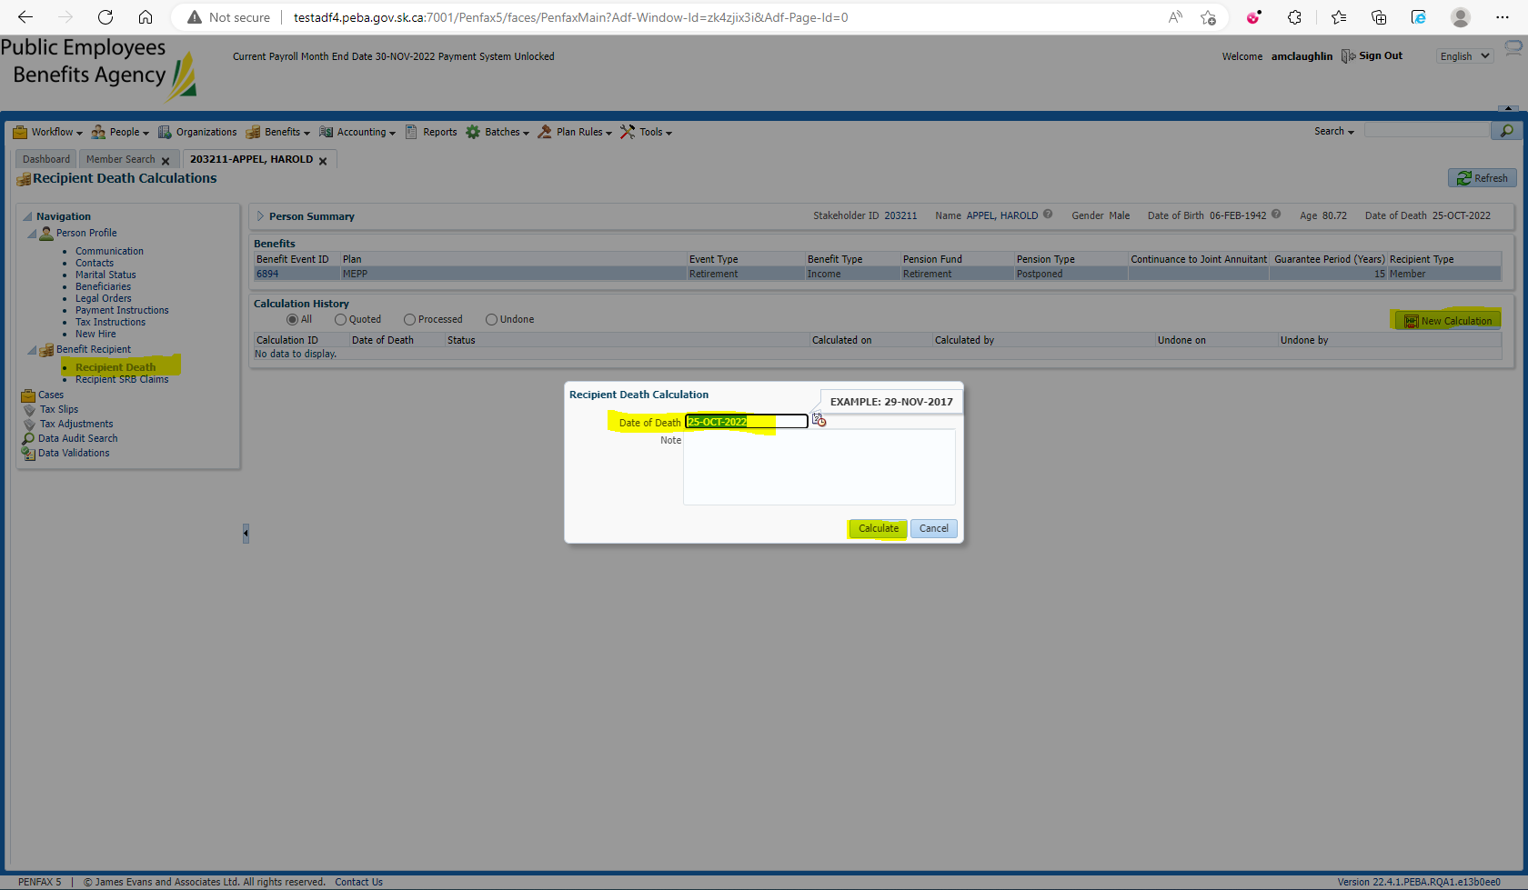

Verify the Lump Sum has been calculated correctly, Check the Pay as Lump Sum Box, Process, and Process Recipient:

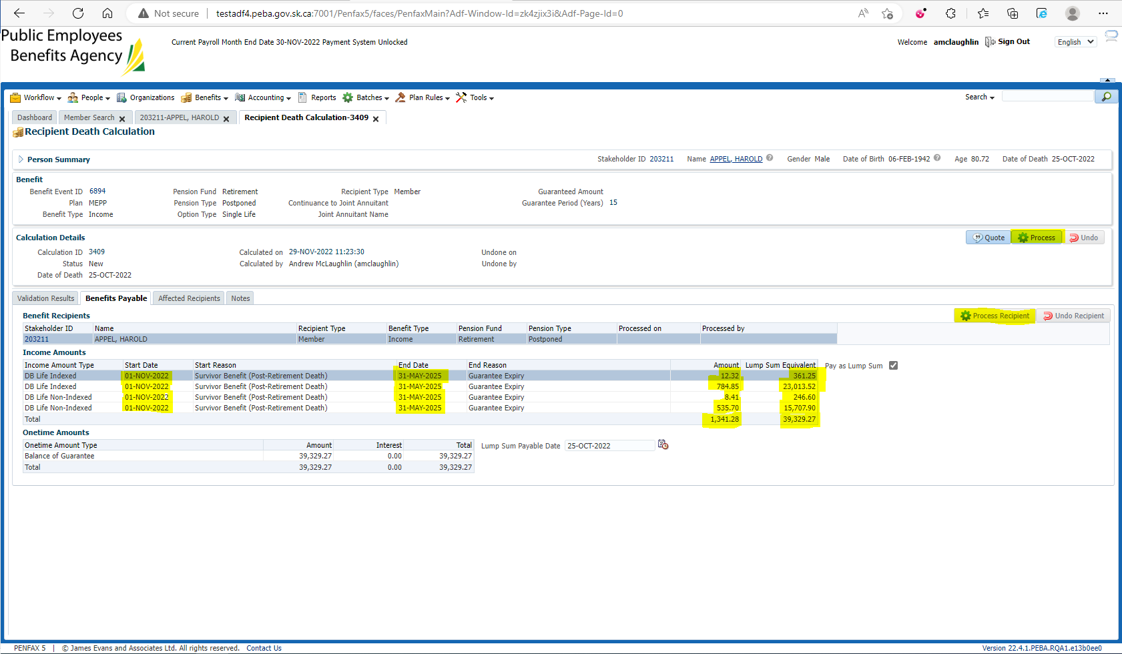

$39,329.27 matches production calculation

31 months of payments remain (Nov 2022 – May 2025)

$12.32 * 31 = $381.92

$784.85 * 31 = $24,330.35

$8.41 * 31 = $260.71

$535.70 * 31 = $16,606.70

$1,314.28 * 31 = $40,742.68

Verify under the member’s Benefit Recipient that Lump Sum amount carries over:

